Experiment 2: To understand the concepts of data frames and packages in python.
Pandas DataFrame is two-dimensional size-mutable, potentially heterogeneous tabular data structure with labeled axes (rows and columns). A Data frame is a two-dimensional data structure, i.e., data is aligned in a tabular fashion in rows and columns. Pandas DataFrame consists of three principal components, the data, rows, and columns.

Ex 1: Creating a Pandas DataFrame:
import pandas as pd
# list of strings
lst = ['item1', 'item2', 'item3', 'item4', 'item5', 'item6', 'item7']
# Calling DataFrame constructor on list
df = pd.DataFrame(lst)
print(df)
Ex 2: Creating DataFrame from ndarray/lists:
# Python code demonstrate creating
# DataFrame from dict narray / lists
# By default addresses.

import pandas as pd

# intialise data of lists.
data = {'Name':['ram', 'shyam', 'hari', 'madhab'],
'Age':[20, 21, 19, 18]}

# Create DataFrame
df = pd.DataFrame(data)

# Print the output.
print(df)

Ex 3: Column Selection
# Import pandas package
import pandas as pd

# Define a dictionary containing employee data
data = {'Name':['Jai', 'Princi', 'Gaurav', 'Anuj'],
'Age':[27, 24, 22, 32],
'Address':['Delhi', 'Kanpur', 'Allahabad', 'Kannauj'],
'Qualification':['Msc', 'MA', 'MCA', 'Phd']}

# Convert the dictionary into DataFrame
df = pd.DataFrame(data)

# select two columns
print(df[['Name', 'Qualification']])

Experiment 2: Plotting Graphs using Libraries in python

For online compiler use:
https://cocalc.com/features/jupyter-notebook
select kernel: python

Example 1: Creating a Simple Graph using NetworkX
import networkx as nx
import matplotlib.pyplot as plt

# Create an empty graph
G = nx.Graph()

# Add nodes
G.add_nodes_from([1, 2, 3, 4])

# Add edges (connections between nodes)
G.add_edges_from([(1, 2), (2, 3), (3, 4), (4, 1)])

# Draw the graph
nx.draw(G, with_labels=True, node_color='lightblue', edge_color='gray', node_size=2000, font_size=15)
plt.show()
Explanation:
- Uses NetworkX to create an undirected graph.
- Adds nodes (1, 2, 3, 4) and edges connecting them.
- Uses Matplotlib to visualize the graph.
Output:
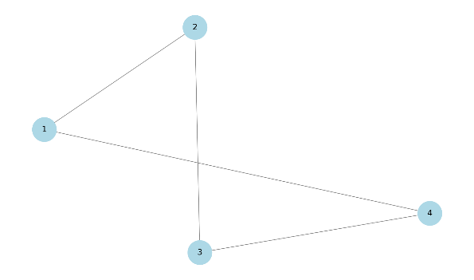

Example 2: Directed Graph (Digraph)

import networkx as nx
import matplotlib.pyplot as plt
G = nx.DiGraph() # Create a directed graph

# Add nodes and edges
G.add_edges_from([(1, 2), (2, 3), (3, 4), (4, 1)])

# Draw the directed graph
nx.draw(G, with_labels=True, node_color='orange', edge_color='red', node_size=2000, font_size=15, arrows=True)
plt.show()
Explanation:
- Uses nx.DiGraph() for a directed graph (digraph).
- Adds edges with directions (arrows).
- Visualizes using Matplotlib with directional edges.
Output:
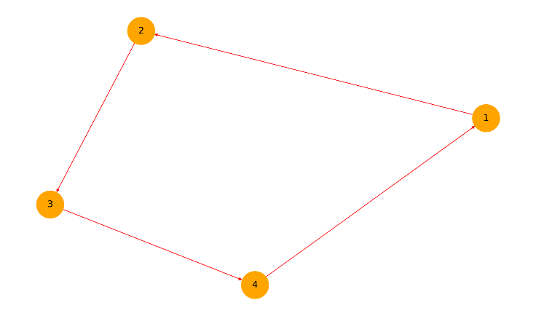

Example 3: Weighted Graph
import networkx as nx
import matplotlib.pyplot as plt
G = nx.Graph()

# Add edges with weights
G.add_weighted_edges_from([(1, 2, 4.5), (2, 3, 2.1), (3, 4, 3.8), (4, 1, 1.5)])

# Get edge labels (weights)
edge_labels = nx.get_edge_attributes(G, 'weight')

# Draw the graph
pos = nx.spring_layout(G) # Positioning of nodes
nx.draw(G, pos, with_labels=True, node_color='lightgreen', edge_color='blue', node_size=2000, font_size=15)
nx.draw_networkx_edge_labels(G, pos, edge_labels=edge_labels, font_size=12) # Display weights

plt.show()
Explanation:
- Creates a weighted graph, where each edge has a numeric weight.
- Uses nx.get_edge_attributes() to extract weights and display them.
Output:
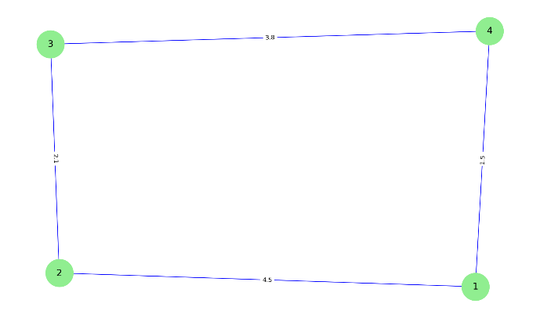

Example 4: Adjacency List Representation

import networkx as nx
import matplotlib.pyplot as plt
from collections import defaultdict
# Graph as an adjacency list
graph = defaultdict(list)

# Function to add edges
def add_edge(graph, u, v):
graph[u].append(v)
graph[v].append(u) # Undirected graph

# Adding edges
add_edge(graph, 1, 2)
add_edge(graph, 2, 3)
add_edge(graph, 3, 4)
add_edge(graph, 4, 1)

# Print adjacency list
for node, neighbors in graph.items():
print(f"Node {node}: {neighbors}")
Explanation:
- Uses defaultdict to represent a graph as an adjacency list.
- Implements a function add_edge() to add edges between nodes.
- Outputs a simple adjacency list format.
Output:
Node 1: [2, 4]
Node 2: [1, 3]
Node 3: [2, 4]
Node 4: [3, 1]

Example 5: Adjacency Matrix Representation
import numpy as np
import networkx as nx
import matplotlib.pyplot as plt
# Number of nodes
n = 4

# Create an empty adjacency matrix
adj_matrix = np.zeros((n, n), dtype=int)

# Function to add edges
def add_edge_matrix(matrix, u, v):
matrix[u-1][v-1] = 1
matrix[v-1][u-1] = 1 # Undirected graph

# Add edges
add_edge_matrix(adj_matrix, 1, 2)
add_edge_matrix(adj_matrix, 2, 3)
add_edge_matrix(adj_matrix, 3, 4)
add_edge_matrix(adj_matrix, 4, 1)

# Print adjacency matrix
print("Adjacency Matrix:")
print(adj_matrix)
Explanation:
- Uses NumPy to create an adjacency matrix representation.
- Adds edges and prints the matrix form of the graph.
Output:
Adjacency Matrix:
[[0 1 0 1]
[1 0 1 0]
[0 1 0 1]
[1 0 1 0]]

Conclusion:
These Python examples introduce graph representation and visualization using:
- NetworkX (Graph manipulation and visualization).
- Matplotlib (Graph plotting).
- Defaultdict (Adjacency list representation).
- NumPy (Adjacency matrix representation).
Bottom of Form

